

**Other Project issues:**

**Penwortham bypass and Cuerden Strategic Site Road infrastructure** –Delay in determination of planning applications could affect future programme.

**Lancaster Canal Towpath –**

Scheme costs exceeds agreed 106 – legal advice being sought.

**Tom Benson Way –**

Ecological issues will delay the scheme

**Preston bus station – Youth Zone** –

Additional LCC services need to be accommodated in the new building – might require significant redesign – scheme delayed.

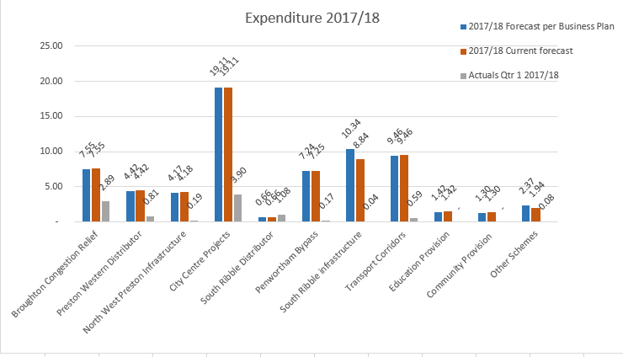

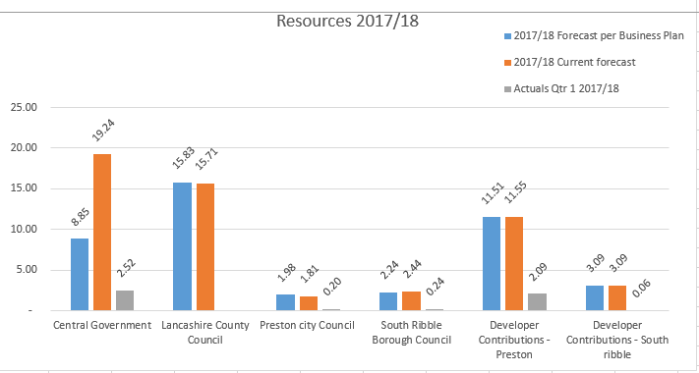

**Movements in the programme:**

**Broughton bypass:** Early completion in Q3.

**Penwortham Bypass:** Planning application now being determined in Q2 due to the requirement to respond to technical representation to the planning application.

**New Ribble Crossing Feasibility Study –** Study will now complete in Q2 as opposed to Q1, due to technical details which require more analysis than anticipated.

**Bamber Bridge –** following the detailed design process, phase 2 of the scheme is now expected to complete in Q1 2018/19.

**Cuerden Strategic Site Road Infrastructure –** planning application is now due to be determined in Q2 due to additional information being required.

**Chart: Scheme status - overview**

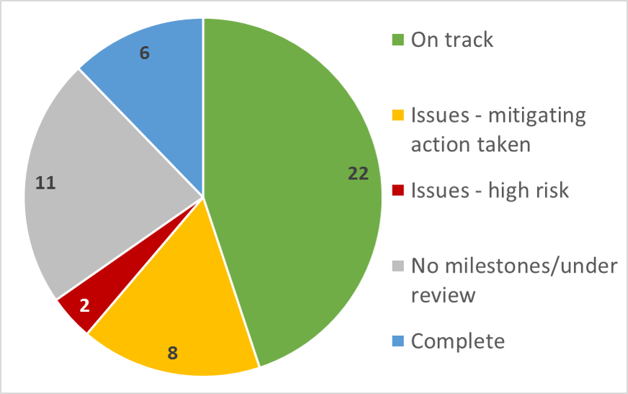

**Key Implementation Issues:**

**PWD and EWLR–** The planning application for these schemes will not be determined until 4th October. This is due to the requirement to respond to complex technical representation to the application. Officers are preparing a detailed report on these matters to be considered at a future Executive and Stewardship board meeting.

**Pickerings Farm Link Road –** Discussions are ongoing with Network Rail regarding a new bridge over the WCML and the associated cost implications for the City Deal. Negotiations with Taylor Wimpey over a Collaboration Agreement are ongoing. It is anticipated that this agreement will be finalised by October 2017. It is expected that consultants will be procured by February 2018. The planning application is programmed to be submitted in Q4 Year 5.

**Fishergate Phase 3** – A funding proposal for this scheme is being prepared in order to address increased costs.

**City Deal schemes – Overview of progress against milestones for Quarter 1 – 2017/18**

|  |  |  |  |  |  |
| --- | --- | --- | --- | --- | --- |
| **No.** | **REF** | **Scheme name** | **Q1** | **Forward RAG** | **Status** |
|  | T01-01 | A6 Broughton Bypass |  |  | On site |
|  | T01-02 | Preston Western Distributor (PWD) |  |  | planning |
|  | T01-03 | East West Link Road (EWLR) |  |  | planning |
|  | T01-04 | Cottam Parkway (business case) |  |  | underway |
|  | T03-01 | Preston Bus Station – concrete repairs/car park |  |  | On site |
|  | T03-02 | Preston Bus Station – refurb of concourse |  |  | On site |
|  | T03-04 | Preston bus Station – on site highways works |  |  | On site |
|  | N/A | Preston bus Station – off site highways works |  |  | Not started |
|  | T03-08 | Fishergate Central Gateway – Ph3 |  |  | Under review |
|  | T04-01 | Penwortham bypass |  |  | planning |
|  | T04-07 | A582 Pope Lane roundabout |  |  | On site |
|  | T04-08 | A582 south Ribble Western Distributor dualling (SRWD) |  |  | No milestones |
|  | T04-09 | Pickerings Farm Link Road |  |  | Under review |
|  | **T04-10** | **New Ribble Crossing – feasibility study** |  |  | **underway** |
|  | T05-03 | Cuerden Strategic Site – road infrastructure |  |  | Planning |
|  | T05-01 | Heatherleigh and Moss Lane – Croston Road spine road |  |  | No milestones |
|  | T05-02 | Moss Side Test Track – road infrastructure |  |  | Planning |
|  | P01-01 | Broughton/Fulwood (North of M55) |  |  | Planning |
|  | P01-02 | Broughton/Fulwood (South of M55) |  |  | Under review |
|  | P01-03 | North West Preston/Cottam/Ingol/City Centre |  |  | Under review |
|  | P01-04 | Warton to Preston Distributor |  |  | Under review |
|  | P02-01 | Longridge/Grimsargh/Ribbleton/City Centre |  |  | Under review |
|  | P03-01a | PWD to Samlesbury – New Hall Lane Local Centre (local centre) |  |  | On site |
|  | P03-01b | PWD to Samlesbury – New Hall Lane Local Centre (corridor) |  |  | Under review |
|  | **P03-02** | **City Transport Plan** |  |  | **underway** |
|  | P04-01 | Hutton/Higher Penwortham/City Centre |  |  | Under review |
|  | P04-02 | North of Lostock Lane |  |  | Under review |
|  | P05-01 | South of Lostock Lane |  |  | Under review |
|  | P06-01 | Bamber Bridge/City Centre |  |  | On site |
|  | **NA03** | **Corridors master planning** |  |  | **underway** |
|  | C01-04 | Lancaster Canal Towpath |  |  | Not started |
|  | C01-05 | Tom Benson Way |  |  | Not started |
|  | C01-01 | Guild Wheel Upgrade Link – P1 Bluebell Way |  |  | Design |
|  | C01-02 | Guild Wheel Upgrade Link – P2 Watery Lane |  |  | Design |
|  | C02-01 | Grimsargh Green |  |  | Not started |
|  | C03-04 | East Cliff Cycle Link and Bridge |  |  | Under review |
|  | C03-01 | Preston bus station – Youth zone |  |  | Design |
|  | C03-05 | Expanded City Cultural Development programme |  |  | underway |
|  | **C04-01** | **Landmark Features – P2 Iron Horse** |  |  | **active** |
|  | C05-01 | St Catherine's Park – Phase 2 |  |  | Design |
|  | **NA-02** | **City Deal Cycling and Walking Delivery Plan** |  |  | **underway** |
|  | NA-01 | Leisure Development Plan |  |  | underway |
|  | C05-06 | Central Park Development Plan |  |  | underway |
|  | **T03-09** | **Fishergate winckley Sq – Ph 1 THI (Cannon Street)** |  |  | **complete** |
|  | C04-02 | Landmark Features – P3 Leyland Tractor |  |  | complete |
|  | T03-07 | Fishergate central Gateway – Ph2 |  |  | complete |
|  | C03-02 | Fishergate Winckley Square – P2 Winckley Sq Gardens |  |  | complete |
|  | C03-03 | East Cliff Cycle Hub |  |  | complete |
|  | T04-06 | A582 Tank Roundabout |  |  | complete |

Milestone met/on track = **GREEN**

Milestone not met/ uncertainty about funding/delivery options but mitigating action being taken = **AMBER**

Milestone not met/risk to programme/delay = **RED**

More information about scheme milestones and delivery can be found in Appendix 'B'

The finance model can also be found in Appendix 'C'.

**Implementation update - Quarter 1 April-June 2017 (Appendix 'A')**

This summary provides an overview of how the City Deal Programme has performed during quarter 1 - Apr-June 2017